**CSE5335: Web Data Management (Fall 2018)**

**Project # 3**

This assignment will cover several chapters (5,6,7,8)

For this assignment, you have the following task

1. Create a new folder for the Petstore
2. Modify the HomePage to implement the two-column page layout
3. Modify the pet.css to configure the two-column page layout
4. Modify the about page to use a table
5. Save your folder as yourname_assignment3
6. Include in your folder all the pages of the project. Compress and submit.
7. Make sure that you page shows responsive web design. It should show configurations in the CSS for Desktop, Tablets and Smartphones

**Submitting only screenshots of the project will give a grade of 0.**

1. Use same colors as in previous projects.
2. For the table use:

1) table is centered

2) takes up 90% of the container

3) 0 border spacing

4) background color in alternate rows use a class of the nth of type pseudo class to configure odd table rows.

Colors #666666 (for the text), #FFFFFF (for the background), #000033 (for the header text background)

Font: Verdana, Arial or any sans-serif font.

Style for the h1: 200%-line height

Style for the h2: color: #3399CC; font-family: Georgia, serif

Style for the nav element, bold text, #90C7E3 (for the nav background);

Styles for the footer element selector that configure background color, font size ( .70 em) italics and centered text.

Configure index.html and about.html content that is centered 80% width (use a style rule with id named wrapper)

index.html

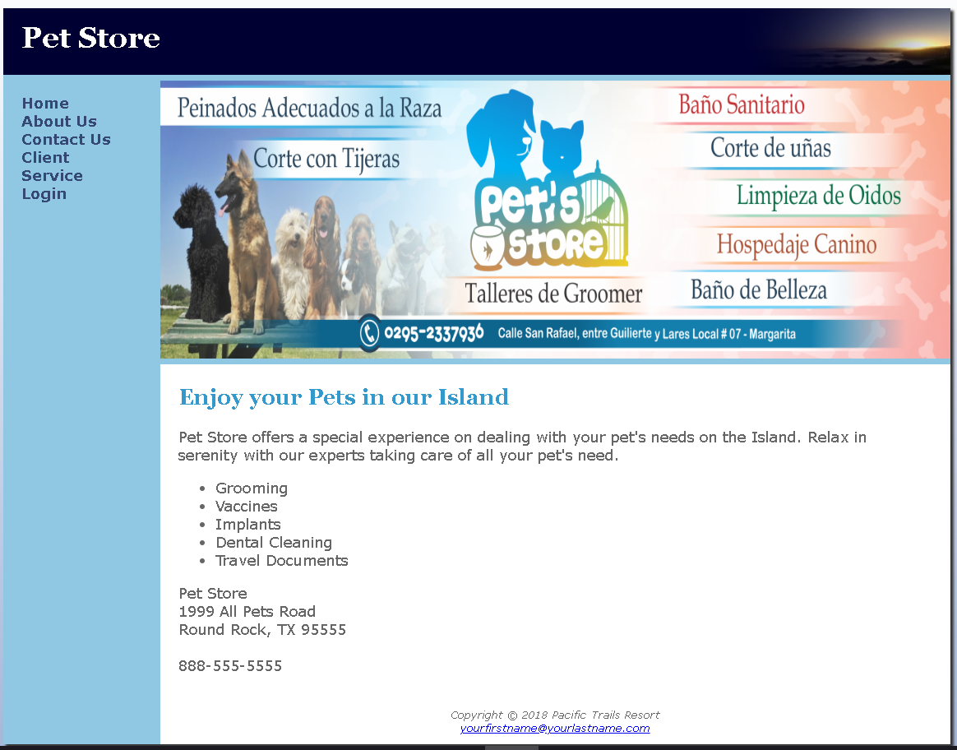

About.html

